Exp-6
Name: LAKSHMI REDDY Y
Reg.No:192324077
import cv2
import numpy as np
import matplotlib.pyplot as plt
import time
import urllib.request
url = 'https://upload.wikimedia.org/wikipedia/commons/7/7d/Dog_face.png'

headers = {'User-Agent': 'Mozilla/5.0 (Windows NT 10.0; Win64; x64) AppleWebKit/537.36 (KHTML, like Gecko) Chrome/58.0.3029.110 Safari/537.3'}
req = urllib.request.Request(url, headers=headers)

try:
with urllib.request.urlopen(req) as response, open('sample.jpg', 'wb') as out_file:
out_file.write(response.read())
print("Image downloaded successfully as 'sample.jpg'")
except urllib.error.HTTPError as e:
print(f"Error downloading image: HTTP Error {e.code} - {e.reason}")
print("The server denied access (403 Forbidden). Please check the URL or try a different image source.")
except Exception as e:
print(f"An unexpected error occurred during image download: {e}")

image = cv2.imread('sample.jpg')

if image is None:
print("Error: Could not load image. Please ensure 'sample.jpg' exists and is not corrupted, or if download failed.")
else:
gray = cv2.cvtColor(image, cv2.COLOR_BGR2GRAY)

start_time = time.time()

blur = cv2.GaussianBlur(gray, (5, 5), 0)
_, otsu_thresh = cv2.threshold(blur, 0, 255, cv2.THRESH_BINARY + cv2.THRESH_OTSU)

end_time = time.time()

processing_time = end_time - start_time
mse = np.mean((gray - otsu_thresh) ** 2)
psnr = 20 * np.log10(255 / np.sqrt(mse)) if mse != 0 else float('inf')

plt.figure(figsize=(10, 5))
plt.subplot(1, 3, 1)
plt.title('Original Image')
plt.imshow(cv2.cvtColor(image, cv2.COLOR_BGR2RGB))
plt.axis('off')

plt.subplot(1, 3, 2)
plt.title('Grayscale + Gaussian Blur')
plt.imshow(blur, cmap='gray')
plt.axis('off')

plt.subplot(1, 3, 3)
plt.title("Otsu's Thresholding")
plt.imshow(otsu_thresh, cmap='gray')
plt.axis('off')
plt.show()

print("===== Performance Verification ====")
print(f"Otsu's Threshold Value: {_}")
print(f"Processing Time: {processing_time:.4f} seconds")
print(f"PSNR (dB): {psnr:.2f}")
output:
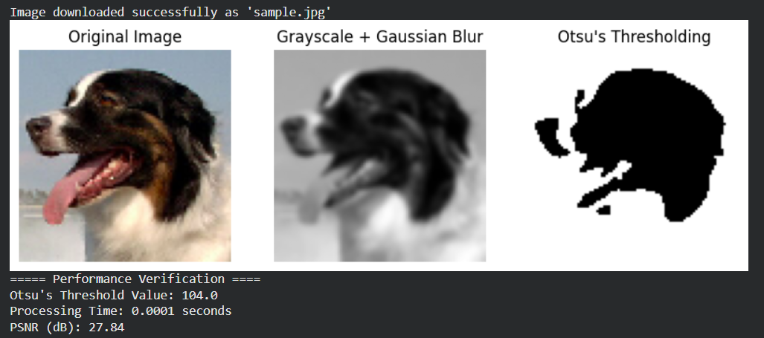
Exp-7
import cv2
import numpy as np
import matplotlib.pyplot as plt
import time

image = cv2.imread('sample.jpg')
gray = cv2.cvtColor(image, cv2.COLOR_BGR2GRAY)
start_time = time.time()
blur = cv2.GaussianBlur(gray, (5, 5), 0)
ret, thresh = cv2.threshold(blur, 0, 255, cv2.THRESH_BINARY_INV + cv2.THRESH_OTSU)
kernel = np.ones((3, 3), np.uint8)
opening = cv2.morphologyEx(thresh, cv2.MORPH_OPEN, kernel, iterations=2)
sure_bg = cv2.dilate(opening, kernel, iterations=3)
dist_transform = cv2.distanceTransform(opening, cv2.DIST_L2, 5)
ret, sure_fg = cv2.threshold(dist_transform, 0.7 * dist_transform.max(), 255, 0)
sure_fg = np.uint8(sure_fg)
unknown = cv2.subtract(sure_bg, sure_fg)
ret, markers = cv2.connectedComponents(sure_fg)
markers = markers + 1
markers[unknown == 255] = 0
markers = cv2.watershed(image, markers)
image[markers == -1] = [255, 0, 0]
end_time = time.time()
processing_time = end_time - start_time
mse = np.mean((gray - cv2.cvtColor(image, cv2.COLOR_BGR2GRAY)) ** 2)
psnr = 20 * np.log10(255 / np.sqrt(mse)) if mse != 0 else float('inf')
plt.figure(figsize=(10, 5))
plt.subplot(1, 3, 1)
plt.title('Original')
plt.imshow(cv2.cvtColor(cv2.imread('sample.jpg'), cv2.COLOR_BGR2RGB))
plt.axis('off')
plt.subplot(1, 3, 2)
plt.title('Thresholded')
plt.imshow(thresh, cmap='gray')
plt.axis('off')
plt.subplot(1, 3, 3)
plt.title('Watershed Result')
plt.imshow(cv2.cvtColor(image, cv2.COLOR_BGR2RGB))
plt.axis('off')
plt.show()
print("===== Performance Verification =====")
print(f"Processing Time: {processing_time:.4f} seconds")
print(f"PSNR (dB): {psnr:.2f}")
output:
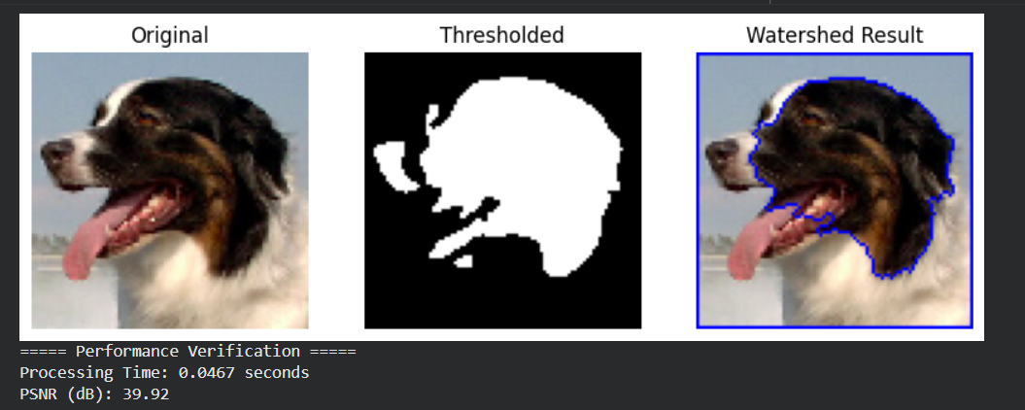
Exp-8
import tensorflow as tf
from tensorflow.keras.models import Sequential
from tensorflow.keras.layers import Dense
from tensorflow.keras.optimizers import Adam
from sklearn.datasets import make_moons
from sklearn.model_selection import train_test_split
from sklearn.preprocessing import StandardScaler
from sklearn.metrics import accuracy_score
import numpy as np

# Generate sample data (like the Playground)
X, y = make_moons(n_samples=1000, noise=0.2, random_state=42)
X = StandardScaler().fit_transform(X)
X_train, X_test, y_train, y_test = train_test_split(X, y, test_size=0.3, random_state=42)

# Try different configurations
learning_rates = [0.01, 0.001, 0.0001]
activations = ['relu', 'tanh', 'sigmoid']

for lr in learning_rates:
for act in activations:
print(f"\n===== MLP with learning_rate={lr}, activation={act} =====")

model = Sequential([
Dense(8, activation=act, input_shape=(2,)),
Dense(8, activation=act),
Dense(1, activation='sigmoid')
])

optimizer = Adam(learning_rate=lr)
model.compile(optimizer=optimizer, loss='binary_crossentropy', metrics=['accuracy'])

history = model.fit(X_train, y_train, epochs=50, batch_size=16, verbose=0)

y_pred = (model.predict(X_test) > 0.5).astype("int32")
acc = accuracy_score(y_test, y_pred)
print(f"Test Accuracy: {acc:.4f}")

output:
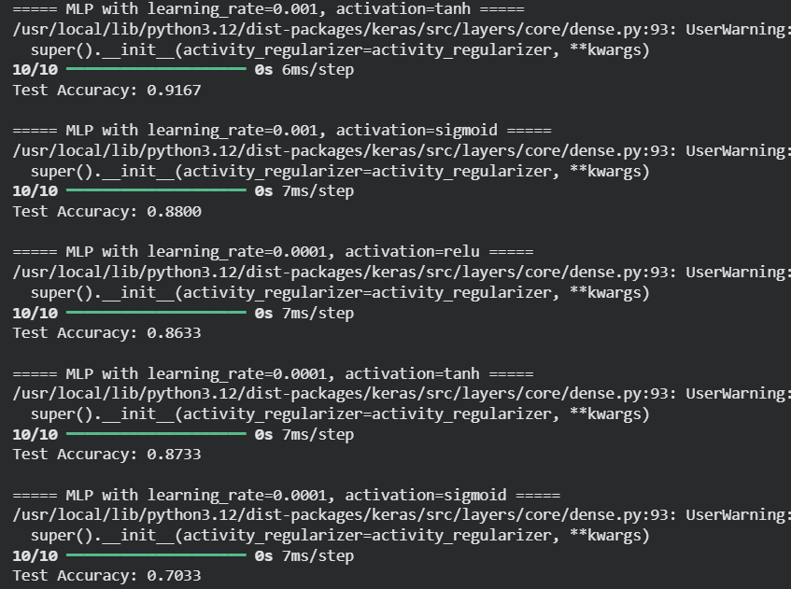
Exp-9
import tensorflow as tf
from tensorflow.keras.models import Sequential
from tensorflow.keras.layers import Dense
from tensorflow.keras.optimizers import Adam
from sklearn.datasets import make_moons
from sklearn.model_selection import train_test_split
from sklearn.preprocessing import StandardScaler
from sklearn.metrics import accuracy_score
import numpy as np
import pandas as pd

# Generate non-linear dataset (like Neural Network Playground)
X, y = make_moons(n_samples=1000, noise=0.2, random_state=42)
X = StandardScaler().fit_transform(X)
X_train, X_test, y_train, y_test = train_test_split(X, y, test_size=0.3, random_state=42)

# Hyperparameter options
hidden_layers = [1, 2, 3]
neurons = [4, 8, 16]
learning_rates = [0.01, 0.001]
activations = ['relu', 'tanh', 'sigmoid']

results = []

# Iterate through all combinations
for hl in hidden_layers:
for hn in neurons:
for lr in learning_rates:
for act in activations:
model = Sequential()
model.add(Dense(hn, activation=act, input_shape=(2,)))
for _ in range(hl - 1):
model.add(Dense(hn, activation=act))
model.add(Dense(1, activation='sigmoid'))

optimizer = Adam(learning_rate=lr)
model.compile(optimizer=optimizer, loss='binary_crossentropy', metrics=['accuracy'])
model.fit(X_train, y_train, epochs=50, batch_size=16, verbose=0)

y_pred = (model.predict(X_test) > 0.5).astype("int32")
acc = accuracy_score(y_test, y_pred)

results.append({
'Hidden_Layers': hl,
'Hidden_Neurons': hn,
'Learning_Rate': lr,
'Activation': act,
'Accuracy': acc
})

# Display performance table
df = pd.DataFrame(results)
print("\n===== Performance Evaluation of Neural Network Architectures =====")
print(df.sort_values(by='Accuracy', ascending=False).reset_index(drop=True))

output:
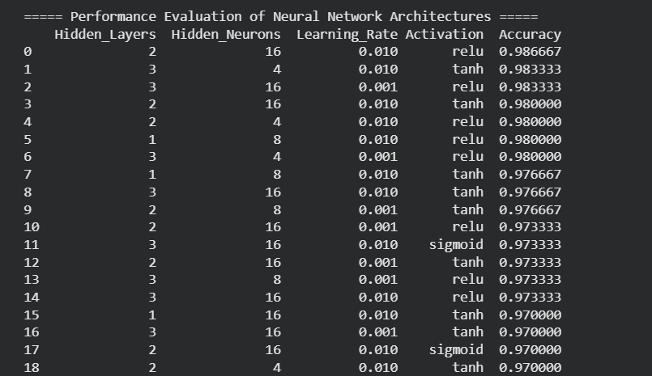

Exp-10
from sklearn.datasets import load_breast_cancer
from sklearn.model_selection import train_test_split
from sklearn.linear_model import LinearRegression
from sklearn.metrics import mean_squared_error, r2_score, accuracy_score
import numpy as np

data = load_breast_cancer()
X = data.data
y = data.target

X_train, X_test, y_train, y_test = train_test_split(X, y, test_size=0.3, random_state=42)

model = LinearRegression()
model.fit(X_train, y_train)
y_pred = model.predict(X_test)
y_pred_class = np.where(y_pred > 0.5, 1, 0)

mse = mean_squared_error(y_test, y_pred)
r2 = r2_score(y_test, y_pred)
acc = accuracy_score(y_test, y_pred_class)

print("Mean Squared Error:", mse)
print("R2 Score:", r2)
print("Accuracy:", acc)
output:
